Print Phase – 4
All files are in this drive folder: Phase_4_Files
***The print orientation is shown in pictures. If the parts fail to print in that orientation, you may change the orientation.

Base Type 1
file Name: bladeHolder.STL
Link: bladeHolder
Infill: 20%.
Wall Loops: 5
Color: White
Precision (Flowrate): High (Low)
Material: PETG
Quantity: 1
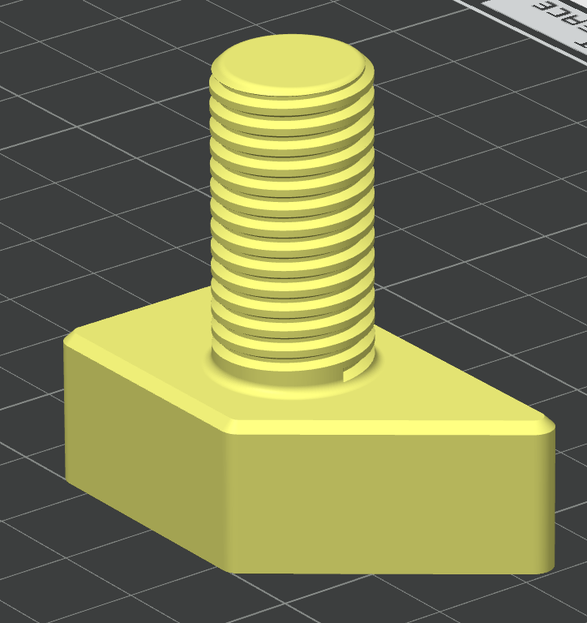

Base Type 2
file Name: spurGear.STL
Link: SpurGear
Infill: 20%.
Wall Loops: 6
Color: White
Precision (Flowrate): High (Low)
Material: PETG
Quantity: 1
